Temperature Chamber Quick Start Guide

# Introduction

This example demonstrates the implementation of a simple temperature chamber controller application using the Tag Bus Data (TBD) framework. This example makes use of a model of the chamber to simulate its I/O and allows users to define the setpoint and PID gains of the control algorithm through a simple user interface. This document describes the minimum number of steps required to get this example running. For more details on how to navigate the framework and customize the example, see the ‘Temperature Chamber Detailed Documentation’.

This example can either be run exclusively on a Windows machine, or it can be run such that the UI runs on Windows while the control logic runs on a controller with a real-time OS. If running on Windows only, follow the instruction steps marked <WINDOWS ONLY>. If running on two targets, follow the instruction steps marked <WINDOWS and cRIO>.

# Execution Steps

1. Open up the Standard Configuration Editor for TBD by navigating in LabVIEW to **Tools>>TBDF>>Launch Standard Configuration Editor…**
2. Navigate within the editor to **Tools>>Edit Plugin Search Paths**.
3. Add a search path to the TBM plugins for this example located at **<LabVIEW examples>\TBD Examples\RT Temperature Controller** if it’s not already there. Also confirm that the standard vi.lib file paths are specified as shown below for the version of LabVIEW that you are using.

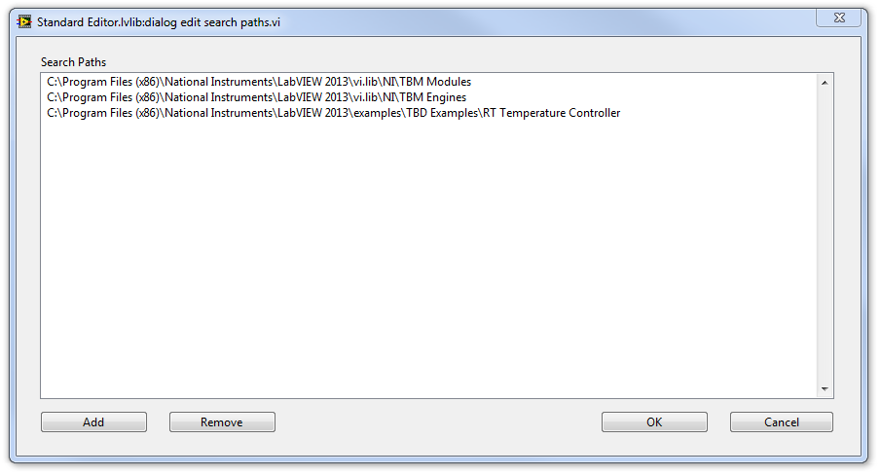

1. Click **OK** to confirm the new search path. The configuration editor will now scan these directories for any TBM plugins and load them into memory.
2. Once the busy cursor disappears, navigate to **File>>Open** and open up the configuration file for this example at **<LabVIEW Examples>\TBD Examples\RT Temperature Controller\SimulatedSystem.pcfg**.

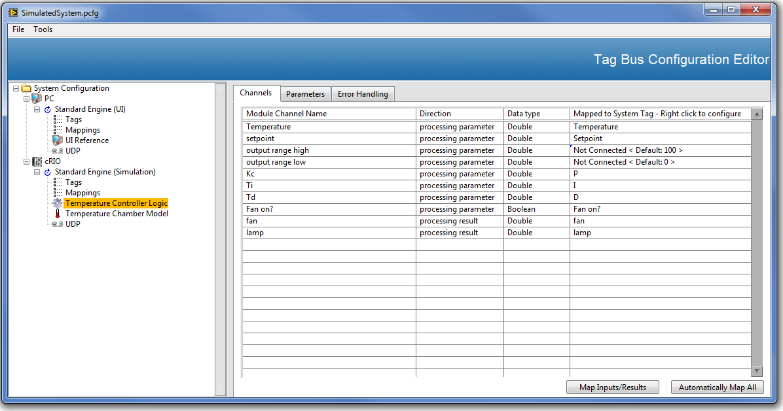

1. <WINDOWS ONLY> If running this configuration purely on your local Windows machine, modify the configuration so that the Engine on the cRIO runs on the PC instead. To do this, click the **Standard Engine (Simulation)** node under the engine and drag it up to the PC.

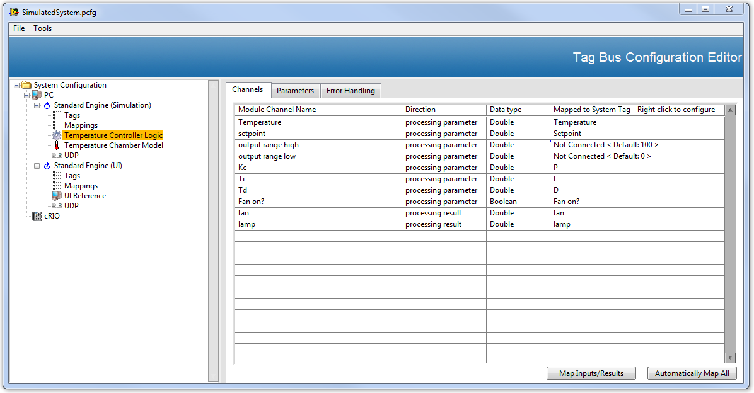

1. Ensure proper IP addresses for both UDP modules.
   1. <WINDOWS ONLY> For the UDP module under each engine, set the **send to address** field on the **Module Settings** tab for both UDP modules to **localhost**.
   2. <WINDOWS and cRIO> For the UDP module under each engine, set the **send to address** on the **Module Settings** tab on the PC UDP module to the IP Address of the cRIO and vice versa for the cRIO UDP module. Be sure to specify the actual IP address and not use a value of **localhost**.
2. Save your changes to the configuration file by navigating within the editor to **File>>Save**.
3. <WINDOWS and cRIO> Click the cRIO target in the configuration editor and enter its IP address in the **IP** field. Then navigate to **Tools>>Deploy** **Tool**, click the cRIO target in the targets list, and then click the **Deploy** button. Ensure that you see a Success dialog appear as shown below.

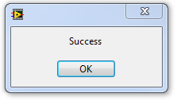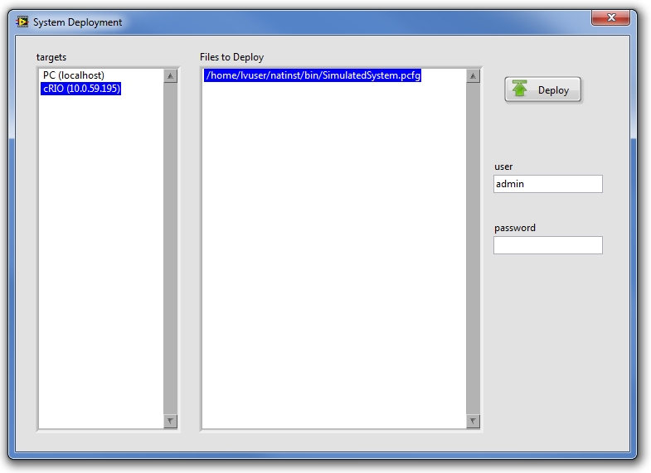

1. Open the **<LabVIEW Examples>\TBD Examples\RT Temperature Controller\Runtime\Temperature Controller Example.lvproj** if it isn’t already open. Then open the **Host Main.vi** from the project and inspect its Block Diagram.

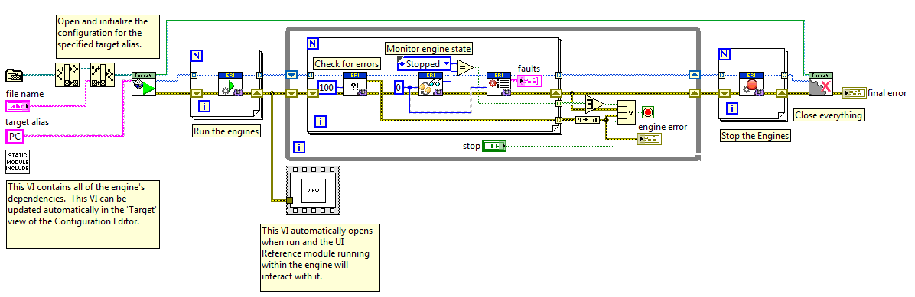

1. Run ‘Host Main.vi’.
2. While still running ‘Host Main.vi’, open up and inspect ‘cRIO Main.vi’ in the project.

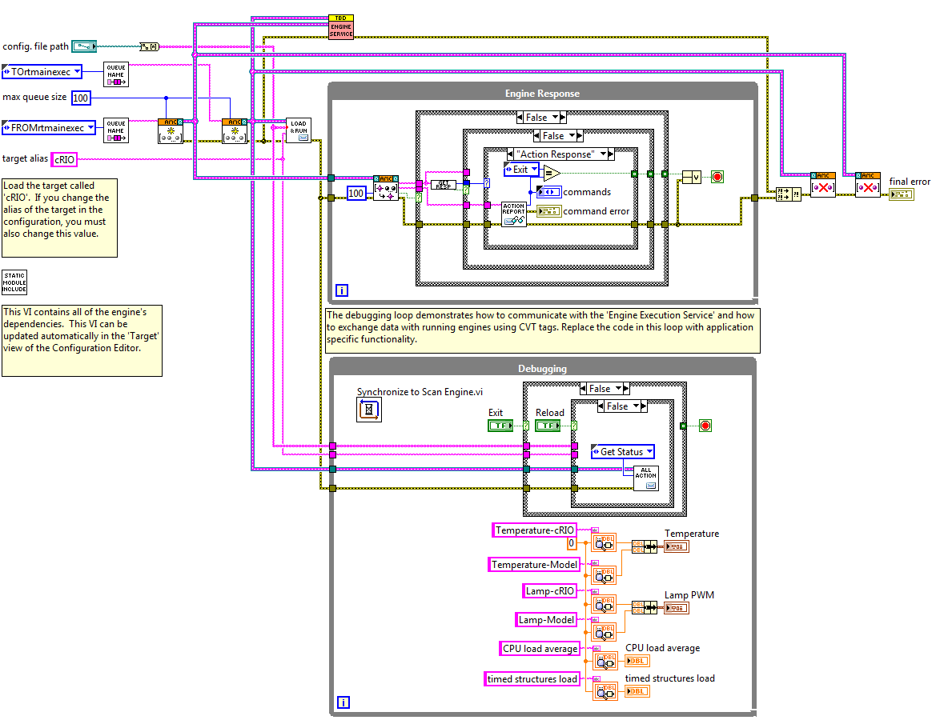

1. <WINDOWS and cRIO> Change the cRIO target’s IP address in the project to match the IP of the controller you want to use.
2. <WINDOWS and cRIO> Run ‘cRIO Main.vi’.

Once running, you should now see data appear on the ‘Host Main.vi’. (If data doesn’t appear, make sure that your IP settings for the UDP module are specified properly in the system configuration and that your firewall isn’t blocking the UDP communication.)

